EM x 64 Bit INSTALLATION STEPS
- Open EnvisionManager Configuration and take Backup of the existing DBs.
[Manage DBs > Backup Database]

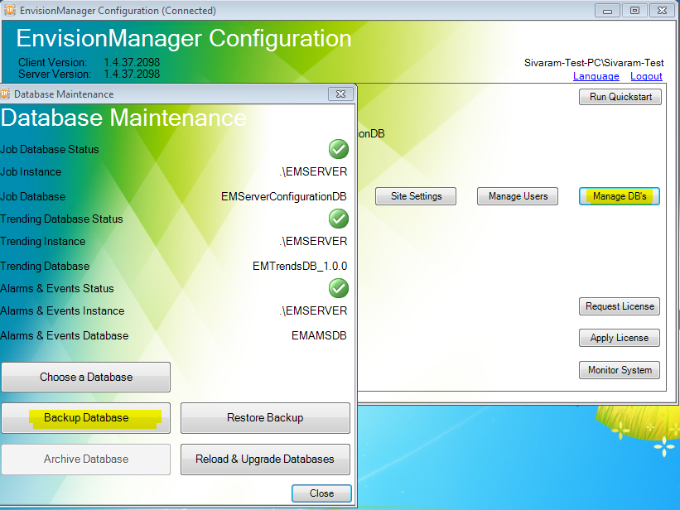
- Uninstall the existing EnvisionManager components from control panel, in the order as listed below:
  - EnvisionSuite
  - EnvisionManager
  - EnvisionSwitch
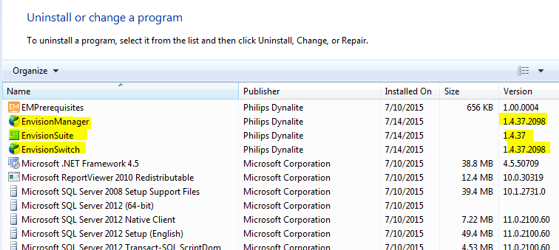
- Restart the machine after uninstalling the above components

- Open the EM 1.5.9.2296 Installer, and right click on “EnvisionSuite_v1.5.9.exe” and select “Run as administrator”

- Follow the prompts and complete the installation. You may ignore, if you get any error screens as below and proceed by clicking “Close” or “OK”

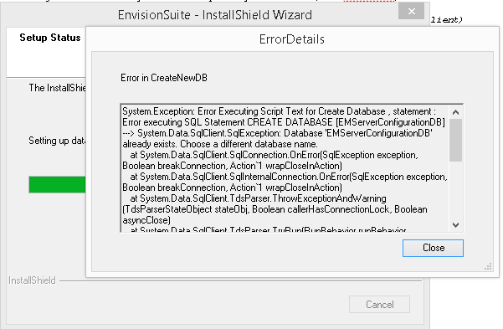

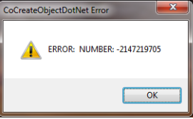

- Installation Screens:
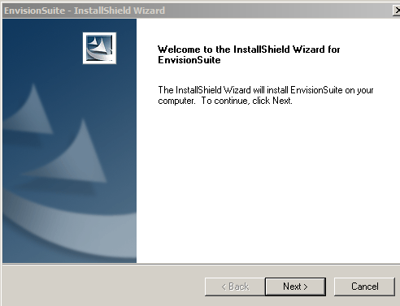

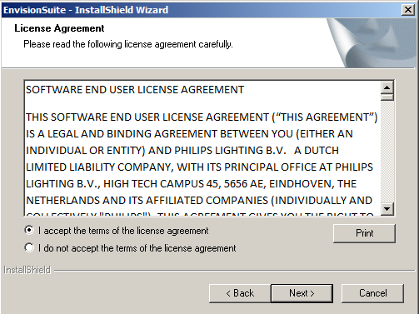

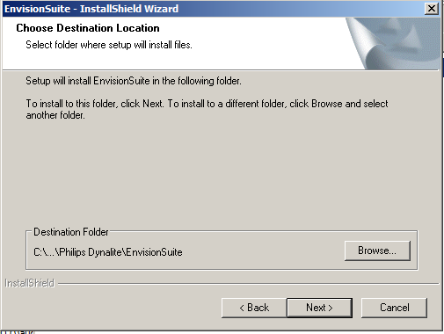

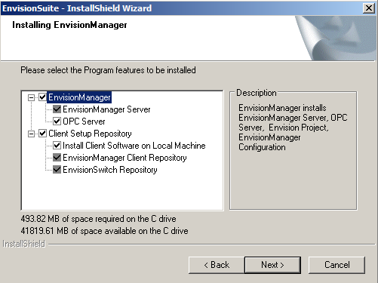

Next and click install

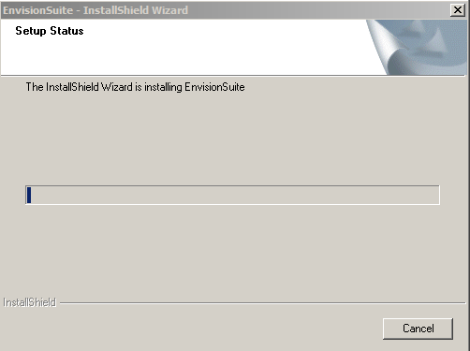

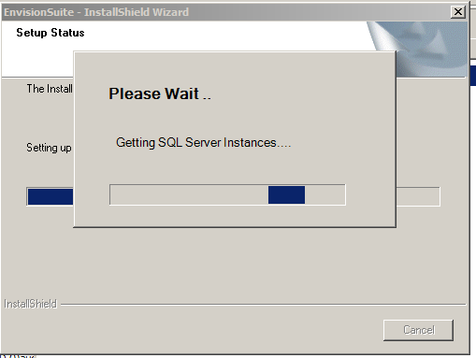

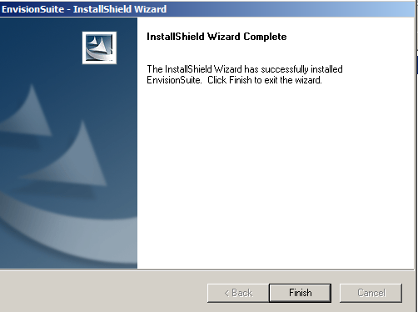

- After installation, check the control panel screen and confirm the EM version numbers

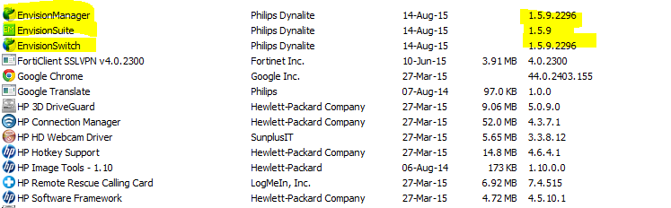

- If you have a client installed in a remote machine, please follow the below steps to upgared the client.

  - Uninstall the client, from control panel.

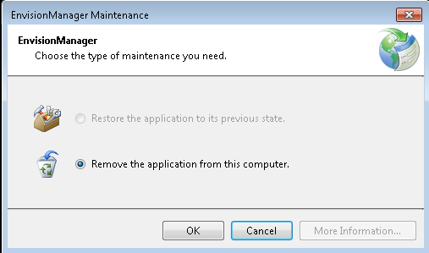

  - Install EM Client via Network Share which will enable automatic upgrades of client in the future ( Whenever the server is upgraded, client machines will automatically upgrade)

Refer Page 24 to 26, of EnvisionManagerInstallationGuide.pdf
